Pre-School Admissions Policy
Scheme of Delegation
Approval by: | FGB
Staff Lead Reviewer: | Cathryn Moore and Donna Evans
Assigned Governor: | Angus Brettell and Derek Bottomley
Date of Last Approval: | November 2025
Date of next review: | November 2027
Review Cycle: | Recommended bi-annually
Publish: | Website

Policy statement
It is our intention to make our setting accessible to children and families from all sections of the local community. We aim to ensure that all sections of our community have access to the setting through open, fair and clearly communicated procedures.

Pre-School class has state funded places for 26 children aged 3 plus, attending 30 hours a week. Children are eligible to attend Pre-School the term after their third birthday.
The places for Pre-School will be allocated the term before their starting term which will allow parents time to return application forms and give notice to any current provider. The date will be set each year by the Head teacher.
Parents can register their child with the school for consideration for a place in the pre-school from birth. However, places are not allocated on a first come first served basis. There is no automatic admission into Crowmarsh Gifford C of E School from Pre-School.
Eligibility Terms
Eligibility Terms Universal Early Education Funding entitlement starts from the term after the child’s 3rd birthday.
Crowmarsh Gifford Pre-School offer three intakes per year. This will take at the start of each term.
30 Hours Extended Childcare Entitlement
Families meeting certain eligibility criteria are legally entitled to a funded early years place of 30 hours a week or 1,140 hours a year. Information on this entitlement is available at www.childcaresupport.tax.service.gov.uk/par/app/overview
Parents who are eligible for 30 hours funding must provide an eligibility code from the link above and provide this prior to the child’s extended hours place being confirmed. If the eligibility code is not provided and confirmed, the child will still be entitled to the Universal 15 hours for that term.
Children may become ineligible for the extended entitlement. Where this happens, there is a grace period (until the end of the half term) during which the child may still attend free of charge.
When the grace period expires, the place will revert to a universal 15-hour place unless the parent/carer is prepared and able to pay for the extended hours.
Parents will be notified that a place is available for their child no later than half a term in advance.
Pre-School Admission Rules
If the number of applications exceeds the number of places then once children who already hold a statement of special educational need or Education, Health and Care Plan have been allocated places the remaining places will be allocated in the following order:
1. Children wishing to take up the full entitlement of 5 full days a week.
2. Looked after and previously looked after children (see Appendix: note 1).
3. Children who have exceptional medical or social needs which can only be met at pre-school supported by written evidence from an appropriate professional person (see Appendix: note 2).
4. Children of staff where either a. The member of staff has been employed at the school for two or more years at the time at which the application for admission to the school is made, (see Appendix: note 3) and/or b. The member of staff is recruited to fill a vacant post for which there is a demonstrable skill shortage (see appendix note 3).
5. Children living within the ecclesiastical parish of the church (see Appendix: Note 4)
6. Children living within the catchment area of the school (see Appendix: note 4).
7. Siblings of children who are attending Crowmarsh Gifford C of E Primary School in Year R (Reception) – Year 5 at the time allocations are made. The children are expected to be on the Crowmarsh Gifford C of E Primary School roll at the time of the proposed admission, or have been offered a place to start in the current academic year (Year R – Year 5). For immediate, in-year admission after the normal point of entry: Siblings of children who are in Year R – Year 6 at the time of admission to the pre-school (see Appendix: note 5).
8. Once the above rules have been applied then any further places will be offered in distance order; using the distance between the child’s Normal Home Address and the school's nearest open entrance gate. We use a computerised system to measure the straight line distance then offer the closest to the gate first. The straight line distance definition: is ‘the distance from your child’s Normal Home Address, as set out by Ordnance Survey, to the nearest open school gate available for pupils to use.’
9. Where the pre-school can take some, but not all, of the children who qualify under one of these rules, we will give priority to children by taking account of the next rule (or rules) in the numbered list to decide who has priority for places. For example, places are offered to catchment siblings before children living in the catchment area without siblings. In each case, distance is used to prioritise which children should be offered places.
10. If it is still not possible to decide between two applicants who are equal distance then an independently scrutinised random allocation will be made to allocate the final place.

Please note the school reserves the right to assess applications on a case-by-case basis should the school believe that they are not able to meet the needs of a particular child. These cases would be reviewed by the governing body, and the parent/carer informed of the outcome.
Applying for a place in Pre-School class
Application forms can be found on the school website or requested from the school office.
We have three school terms, places are allocated at the following times.
- First day of March to start in September
- First day of July to start in January
- First day of December to start in April
Where parents are applying for extended hours (30 hour funded places), they will be required to submit their eligibility code for checking as part of the application process prior to their child’s place being confirmed.
• Parents will be required to show their child’s birth certificate and proof of address when submitting their application form.
• Parents who have been unsuccessful in gaining a place for their child may keep their child’s name on a waiting list in case a place is available at a later date.
• Completing an application form does not guarantee your place in pre-school
Late Applications
Places are allocated within 2 weeks after the application deadline.
Late applications will only be considered alongside timely applications in exceptional circumstances and only if they are received prior to the place allocation being made.
Examples of exceptional circumstances include where a single parent has been ill or has been dealing with the death or serious illness of a close relative. Other circumstances will be considered and each case will be decided on the basis of any independent evidence to support reasons for lateness.

Appendix
The terms used in these rules are as defined in the primary rules above.
The catchment area used is also as defined in the primary rules.
Note 1: Definition of Looked After Child or Previously Looked After Child
For admission purposes a ‘looked after child’ is a child:
• in the care of a local authority in England, or who is being provided with accommodation by a local authority in the exercise of their social services functions. This covers accommodated children and those who are in care under a Care Order or Interim Care Order. This can include living with family or friends, in foster care, in a children’s home, residential school, special school or in supported lodgings. Or
• who was previously looked after and immediately after being looked after became the subject of an adoption, Child Arrangements Order or special Guardianship Order. A Child Arrangements Order is an order setting the arrangements to be made as to the person with whom the child is to live under the Children and Families Act 2014. A Special Guardianship Order appoints a child’s special guardian(s) under Section 14A of the Children’s Act 1989.
This may also include children who appear to have been in state care outside of England and ceased to be in state care as a result of being adopted. A child is regarded as having been in state care in a place outside of England if they were accommodated by a public authority, a religious organisation or any other provider of care whose sole purpose is to benefit society.
For applications under either of these rules, please provide a letter from your child’s Social Worker or other documentary evidence confirming this situation.

Note 2: Exceptional Social and Medical process for nursery admissions
The governing body of Crowmarsh Gifford Primary School will consider the applications under this rule on receipt of information from the parent to indicate strong reasons for the child attending our particular pre-school.
When making an application parents should send evidence from an independent professional person (this might be a Doctor, Health Visitor, or Education Welfare Officer, for example) who knows about the child and supports the application to the nursery.
The evidence must clearly show why our nursery is the only one that will meet your child’s needs, and it should explain what difficulties there would be if your child went to a different nursery.
Note 3: Child of a member of staff
To apply under this rule, you (the parent) need to have been employed at the school for two or more years at the time at which the application for admission to the school is made, AND/OR
Have been recruited to fill a vacant post for which there is a demonstrable skill shortage. This is a post which the school has had difficulty in filling. This might be where the school has taken part in a recruitment drive to fill the post either across the country or worldwide and/or where the post was not filled at the first attempt.
'School staff' includes teaching staff on a permanent or fixed term contract exceeding 11 months in duration, and all other staff on permanent or fixed term contracts exceeding 11 months in duration for posts of in excess of 15 hours per week.
Note 4: Primary School Catchment Areas
The ecclesiastical parish of Crowmarsh Gifford:
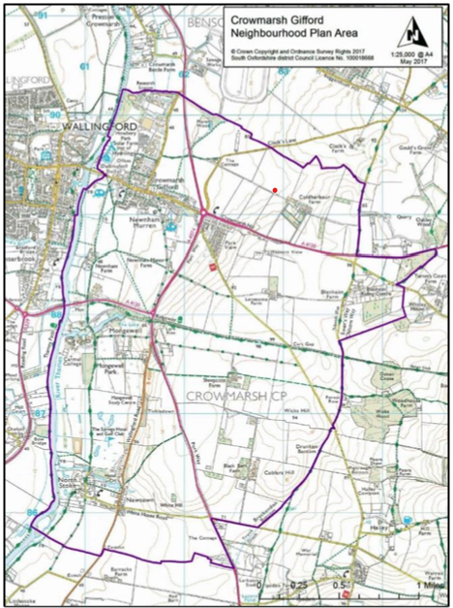

The primary school catchments can be viewed at: https://www.oxfordshire.gov.uk/residents/schools/apply-school-place/find-out-about-schools
Note 5: Definition of sibling
A sibling is a brother or sister.
For admission purposes we mean one of two or more individuals who have one or more parent in common, or any other child (including an adopted or fostered child) who lives at the same address and for whom the parent also has parental responsibility or, (in the case of a fostered child) delegated authority.
When we are allocating places to a class which is covered by the infant class size legislation, if we have one place left and the next child on the list is a twin, triplet or other multiple birth group then both twins (or all the siblings in the case of multiple births) will be admitted.
Whilst that child is in the class they will be an excepted pupil under the Schools Admissions (Infant Class Size) (England) Regulations 2012, which permit Key Stage 1 classes to exceed 30 following the admission of a twin, triplet or other multiple birth group for as long as necessary until a child leaves the class at which point the class will remain at the lower figure.
For admission to a class where infant class size legislation does not apply both twins (or all the siblings in the case of multiple births) would be admitted.

