Homework Year 1 Autumn 2026

Age Appropriate Homework Expectations

Spelling Expectations | Practice spellings for 10 minutes each day.  Age-appropriate words can be found on the class pages of the school website.
Reading Expectations: | Read for 10 minutes each day and record your progress in your Reading Record. Reading Records should be in school every day and will be checked at least once a week.  Please refer to age appropriate ‘Reading Fluency Skills’ on the class pages of the school website.
Maths Expectations: | Count, read and write numbers up to 100 in words and numerals.  Count in steps of 2, 5 and 10.  Number bonds to 10.

Dedicating time each day to homework helps you to form effective learning habits.

Topic Tasks
Please pick activities to complete with your family. Homework should be a positive experience; the discussion & fun you have with your family is just as important as the outcome. Enjoy!

If you were The Very Hungry Caterpillar, what kinds of food might you eat?  Can you write a list of some of your favourite foods?  English  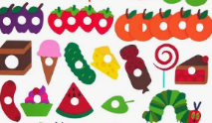 | What is your favourite book?  What do you like about it? Who are the authors and illustrators? Do you have a favourite character?  English  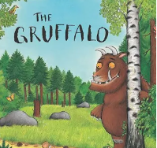 | Read your favourite fairy-tale and change the story by creating your own character.  English  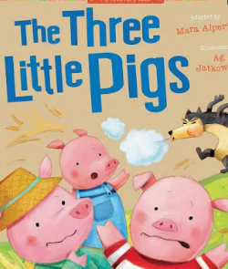
Go on a shape hunt around your home or local area. What shapes can you find?  Maths  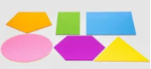 | Can you make number bonds to 10?  Build towers of 10 blocks or lego bricks, then split them into two colours or parts to see how they combine to make 10 e.g.  2 + 8 =10 , 3 + 7 = 10  Maths | Go on an autumn walk – how many different signs of autumn can you find? What different coloured leaves can you find?  Science
Create a badge or poster showing all the groups you belong to e.g. your family, your class, a sports club  RE/PSHE | Design and make a toy using materials you have at home. You could use empty boxes, bottles or bottle tops.  Design and Technology | Collect different materials and describe what they feel like and what they are made from.  Science
Create a piece of autumn artwork. You could use fallen leaves to create leaf rubbings or create an autumn collage. Talk with an adult about seasonal changes during autumn.  Art   | Can you create a map of where you live?  It could be a map of your bedroom, your garden, your road or a local park.  Geography  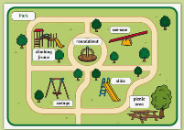 | Ask a parent, grandparent or an older friend about the toys they played with when they were younger.  Are they different to the toys you play with now?  History  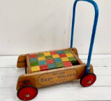

There is no right or wrong way to complete the tasks. Take as long, or as little, time as you like. A large project my take several weeks. Bring Topic Tasks to school in any way you like e.g. email, photo, written, scrap book, artwork, edible… You can send any photos that you take to Mrs Macdonald: HMacdonald3200@crowmarsh-gifford.oxon.sch.uk

Additional learning may be sent home as appropriate.
You can also find useful guides and resources for learning at home on our school website.

